CHAPTER 1 WORKSHEET
Insert the missing directional terms in the blanks of the statements below the diagram.
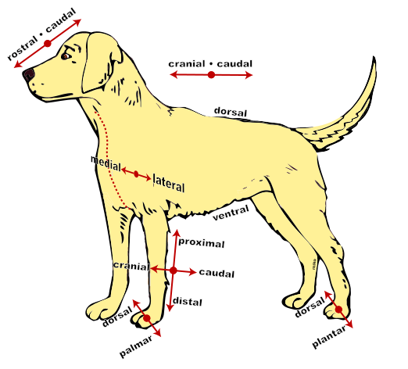
- The head is ____________________________ to the tail.
- The abdomen is _________________________ to the vertebral column (backbone).
- The carpus is ___________________________ to the elbow.
- The hock is ____________________ to the paw.
- The humerus (large bone in the upper portion of the front limb is __________________ to the ulna (small bone in the lower portion of the front limb).
- The lungs are ______________ to the heart.
- The bladder is ____________________ to the stomach.
- The eyes are ______________________ to the ears.
- The eyes are _____________________ to the tip of the nose.
- The mouth is ____________________ to the nasal cavity.
- The heart is ___________________ to the rib cage.
- The phalanges (fingers) are _____________ to the carpus.
- The ears are ___________________ to the brain.
- The tail is ____________________ to the pelvis.
- The atlas (first vertebrae in the backbone) is _________________ to the axis (second vertebrae in the backbone).

