Name of Abnormality | What it looks like: | What Causes it? | What is happening in the heart? | What is the Treatment / Prognosis | Other Information
 | 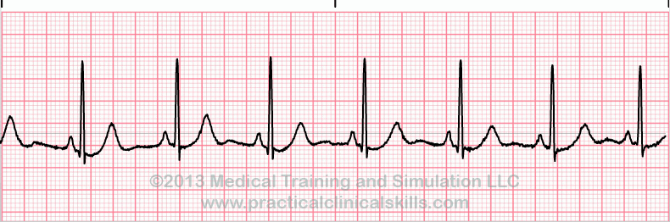
 | 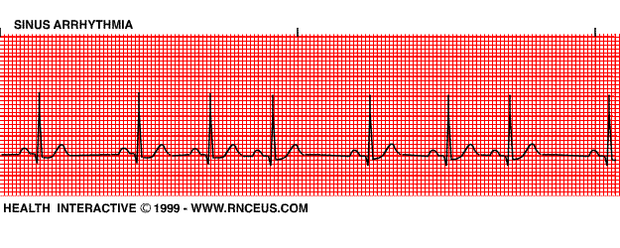
 | 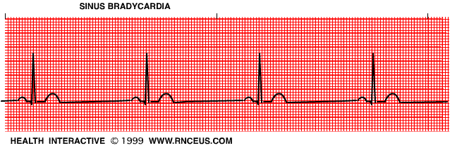
 | 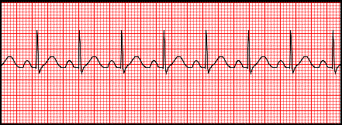
 | 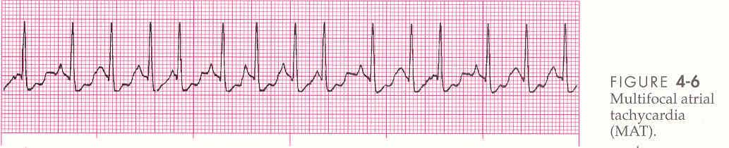
 | 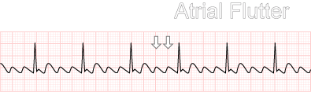
 | 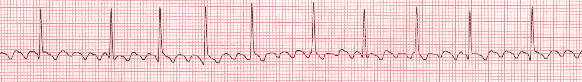
 | 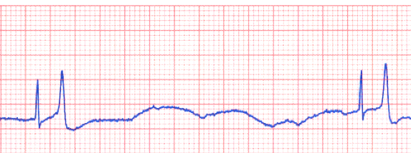
 | 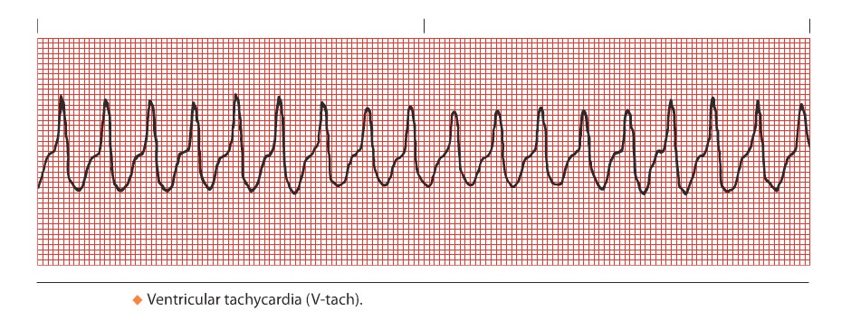
 | 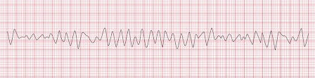
 | 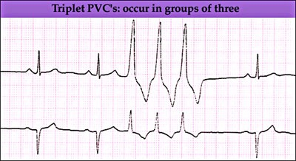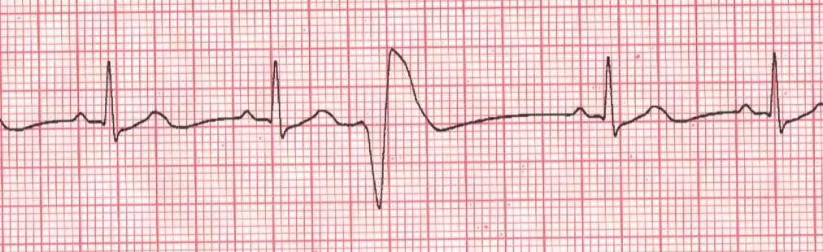
 | 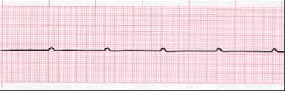
 | 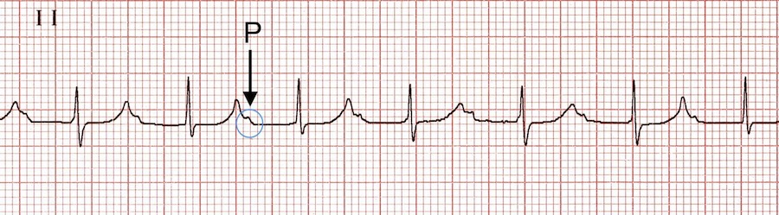
 | 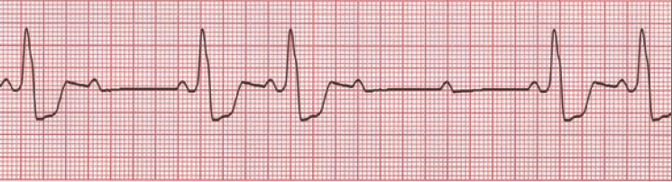
 | 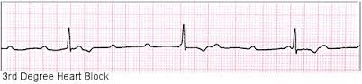
 | 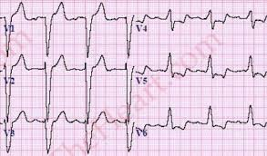
 | 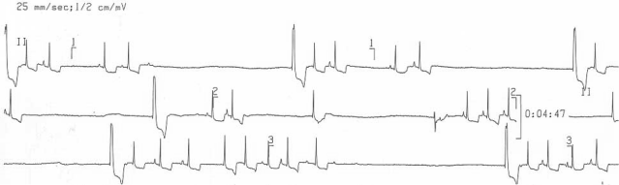
 | 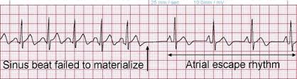
 | 